The Parish Church of St Andrew
Orford with Longford

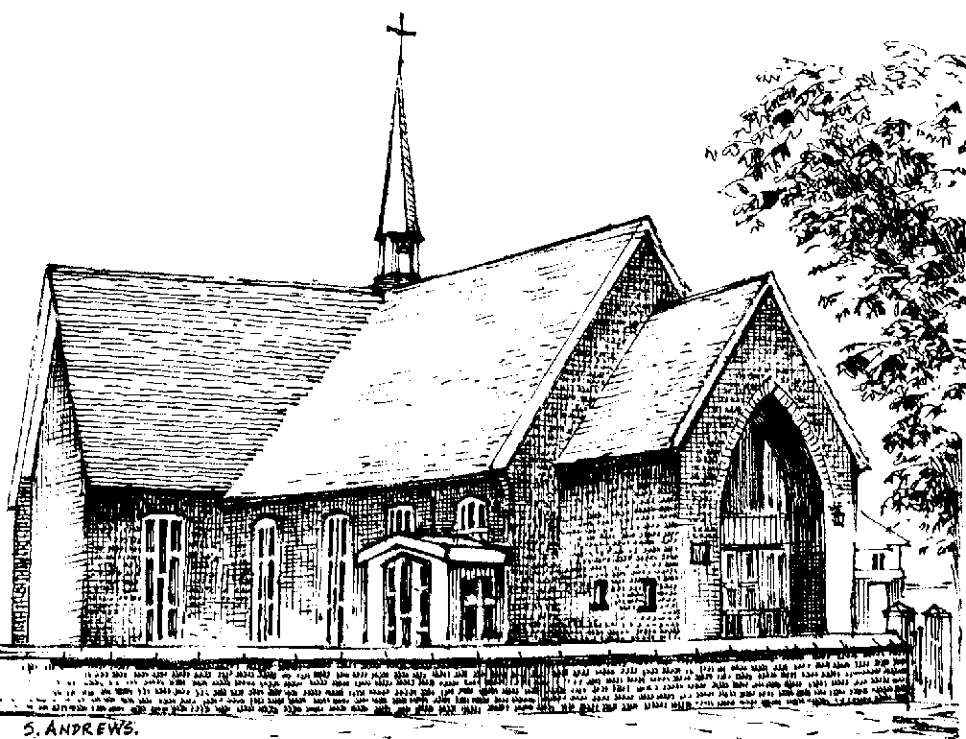

Ada Littlewood
1925 - 2008

Monday 22nd December 2008

Order of Service

ALL STAND as the funeral procession enters the church. Once the family are seated, please SIT.

Introduction

Priest: “Jesus said, ‘I am the resurrection and I am the life; they who believe in me, though they die, yet shall they live, and whoever lives and believes in me shall never die.’” (John 11. 25, 26)

We meet in the name of Jesus Christ, who died and was raised to the glory of God the Father. Grace and mercy be with you. Amen.

The priest introduces the service

Priest: Let us pray:

Almighty God, you judge us with infinite mercy and justice, and love everything you have made. In your mercy turn the darkness of death into the dawn of new life, and the sorrow of parting into the joy of heaven; through our Saviour, Jesus Christ. Amen

All: Merciful Father, hear our prayers and comfort us; renew our trust in your Son, whom you raised from the dead; strengthen our faith that all who have died in the love of Christ will share in his resurrection; who lives and reigns with you, in the unity of the Holy Spirit, one God, now and for ever. Amen

The Ministry of the Word

Hymn: “All things bright and beautiful” (please stand)

All things bright and beautiful,
all creatures great and small,
all things wise and wonderful,
the Lord God made them all.

Each little flower that opens,
each little bird that sings,
he made their glowing colours,
he made their tiny wings:

The purple headed mountain,
the river running by,
the sunset, and the morning
that brightens up the sky:

The cold wind in the winter,
the pleasant summer sun,
the ripe fruit in the garden,
he made them every one:

He gave us eyes to see them,
and lips that we might tell
how great is God almighty,
who has made all things well:

All things bright and beautiful,
all creatures great and small,
all things wise and wonderful,
the Lord God made them all.

The Reading 1 Peter 1. 3-9 [NEB]

A reading from the first letter of Saint Peter

Praise be to the God and Father of our Lord Jesus Christ, who in his great mercy gave us new birth into a living hope by the resurrection of Jesus Christ from the dead! The inheritance to which we are born is one that nothing can destroy or spoil or wither, It is kept for you in heaven, and you, because you put your faith in God, are under the protection of his power until salvation comes—the salvation
which is even now in readiness and will be revealed at the end of time.

This is cause for great joy, even though now you smart tor a little while, if need be, under trials of many kinds. Even gold passes through the assayer’s fire, and more precious than perishable gold is faith which has stood the test. These trials come so that your faith may prove itself worthy of all praise, glory, and honour when Jesus Christ is revealed.

You have not seen him, yet you love him; and trusting in him now without seeing him, you are transported with a joy too great for words, while you reap the harvest of your faith, that is, salvation for your souls.

This is the word of the Lord

Thanks be to God

The Address

Hymn: “I the Lord of sea and sky” (please stand)

1 | I, the Lord of sea and sky,  I have heard my people cry.  All who dwell in dark and sin  my hand will save.  I who made the stars of night,  I will make their darkness bright.  Who will bear my light to them?  Whom shall I send? | 2 | I the Lord of snow and rain,  I have borne my people’s pain.  I have wept for love of them.  They turn away.  I will break their hearts of stone,  give them hearts for love alone.  I will speak my word to them.  Whom shall I send?
 | Here I am, Lord. Is it I Lord?  I have heard you calling in the night.  I will go Lord, if you lead me.  I will hold your people in my heart. | 3 | I, the Lord of wind and flame,  I will tend the poor and lame.  I will set a feast for them.  My hand will save.  Finest bread I will provide  till their hearts are satisfied.  I will give my life to them.  Whom shall I send?

The Prayers:

Priest: God of mercy, Lord of life, you have made us in your image to reflect your truth and light: we give you thanks for Ada, for the grace and mercy she received from you, for all that was good in her life, and especially for the memories we treasure today.

Lord, in your mercy
All: hear our prayer.

Priest: You promised eternal life to those who believe. Remember for good this your daughter Ada as we also remember her. Bring all who rest in Christ, including those we bring to mind today, into the fullness of your kingdom where sins have been forgiven and death is no more.

Lord, in your mercy
All: hear our prayer.

Priest: Your mighty power brings joy out of grief and life out of death. Look in mercy on Kate and David, their families and all who mourn at this time. Give them patient faith in times of darkness. Strengthen them with the knowledge of your love.

Lord, in your mercy
All: hear our prayer.

Priest: Father, you are tender towards your children and your mercy is over all your works. Heal the memories of hurt and failure. Give us the wisdom and grace to use aright the time that is left to us here on earth, to turn to Christ and follow in his steps in the way that leads to everlasting life.

Lord, in your mercy
All: hear our prayer.

God of mercy, entrusting into your hands all that you have made and rejoicing in our communion with all your faithful people, we make our prayers through Jesus Christ our Saviour. Amen.

Priest: Let us pray with confidence as our Saviour has taught us
All: Our Father, who art in heaven, hallowed be thy name; thy kingdom come; thy will be done; on earth as it is in heaven. Give us this day our daily bread. And forgive us our trespasses, as we forgive those who trespass against us. And lead us not into temptation; but deliver us from evil. For thine is the kingdom, the power and the glory, for ever and ever. Amen.

Hymn: “Praise my soul the King of heaven”

1 | Praise, my soul, the King of heaven,  to his feet thy tribute bring;  ransomed, healed, restored, forgiven,  who like me his praise should sing?  Alleluia, Alleluia,  praise the everlasting King. | 2 | Praise him for his grace and favour  to our fathers in distress;  praise him still the same as ever,  slow to chide and swift to bless:  Alleluia, Alleluia,  glorious in his faithfulness.
3 | Father-like, he tends and spares us,  well our feeble frame he knows;  in his hands he gently bears us,  rescues us from all our foes:  Alleluia, Alleluia,  widely as his mercy flows. | 4 | Angels, help us to adore him;  ye behold him face to face;  sun and moon, bow down before him,  dwellers all in time and space:  Alleluia, Alleluia,  praise with us the God of grace.
Commendation and Farewell [please remain standing]

Priest: Let us commend Ada to the mercy of God our Maker and Redeemer.

The coffin is sprinkled with holy water taken from the font

Priest: With this water we call to mind Ada’ baptism. As Christ went through the deep waters of death for us, so may he bring us to the fullness of resurrection life with Ada and all the redeemed.

God our creator and redeemer, by your power Christ conquered death and entered into glory. Confident of his victory and claiming his promises, we entrust Ada to your mercy in the name of Jesus our Lord, who died and is alive and reigns with you, now and for ever. Amen

All: Heavenly Father, in your Son Jesus Christ you have given us a true faith and a sure hope. Strengthen this faith and hope in us all our days, that we may live as those who believe in the communion of saints, the forgiveness of sins and the resurrection to eternal life; through Jesus Christ our Lord. Amen.

Priest: The Lord bless you and watch over you,
the Lord make his face shine upon you and be gracious unto you,
the Lord look kindly on you and give you peace;
and the blessing of God almighty,
the Father, the Son and the Holy Spirit,
be among you and remain with you always. Amen

The Committal (at Walton Lea)

Opening sentence and introduction:

Verses from Psalm 84:

How lovely is thy dwelling place,
O Lord of hosts!
For a day in your courts
is better than a thousand elsewhere.
I would rather be a doorkeeper in the house of my God
than dwell in the tents of wickedness.
No good thing does the Lord withhold
from those who walk uprightly.
O Lord of hosts,
blessed is the one who trusts in you.

A prayer for Ada: Remember O Lord your daughter Ada who has gone before us with the sign of faith, and now rests in the sleep of peace. According to your promises, grant to her and to all who rest in Christ, refreshment, light and peace; through the same Jesus Christ our Lord. Amen

The Committal: We have entrusted our sister Ada to God's mercy, and we now commit her body to be cremated: in sure and certain hope of the resurrection to eternal life through our Lord Jesus Christ, who died, was buried, and rose again for us. To him be glory for ever. Amen

A prayer for Ada’s family and friends: Almighty God, Father of all mercies and giver of all comfort: deal graciously, we pray, with those who mourn, that casting all their care on you, they may know the consolation of your love; through Jesus Christ our Lord. Amen

The Blessing: May God give you his comfort and his peace, his light and his joy, in this world and the next; and the blessing of God almighty, the Father, the Son, and the Holy Spirit, be among you and remain with you always. Amen


Acknowledgement: Common Worship: Pastoral Services, material from which is included in this service, is copyright © The Archbishops’ Council (2000-2002)

